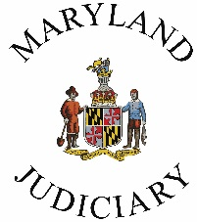
Administrative Office of the Courts
Department of Family Administration
2009-A Commerce Park Drive, Annapolis MD 21401
NOFA #: N19-0001-25I

Jurisdictional Application Modification Cover Sheet
Modification #:
Applicant Organization Name:
Office/Department/Unit (if applicable):
Program Name (if different):
Address:
City: State: ZIP:
Federal Employee Identification Number (FEIN): DUNS (if applicable): NA
Amount Requested: $ Matching Funds: NA
(if applicable)
Applicant Organization Personnel | Name | Phone Number | Email
Administrative Judge/ Organization Director:
Court Administrator/ Administrative Clerk:
Project Manager:

Project Finance Manager:

Authorizing Signatures
By signing below, the applicant agrees to abide by all terms of the Judiciary’s General Conditions as well as the terms of the Special Conditions for FY19 Jurisdictional Grants.

Director/Administrative Authority: | Financial Authority:
Signature | Signature
Printed Name | Printed Name
Title Date Title Date

Please submit signed application modification to: DJFSGrants@MDCourts.gov by April 20, 2018.

Jurisdictional Grant Application Modification

Please use this form to modify the FY19 Grant Application submitted in July of 2017.
The rows will expand as you type. To add rows, position your cursor in the last row of the table, right click, and choose “insert row below.”

COUNTY NAME:

Is this an ADDITION to your FY19 Application or a REVISION? | Line Item | New or Revised Cost | Explanation of Addition or Revision  Please explain both why the line items is needed and how the cost was determined.

Original Amount Requested:
(submitted July 2017)
Changes to Amount Request (+/-):
Total Amount of Final Request:

