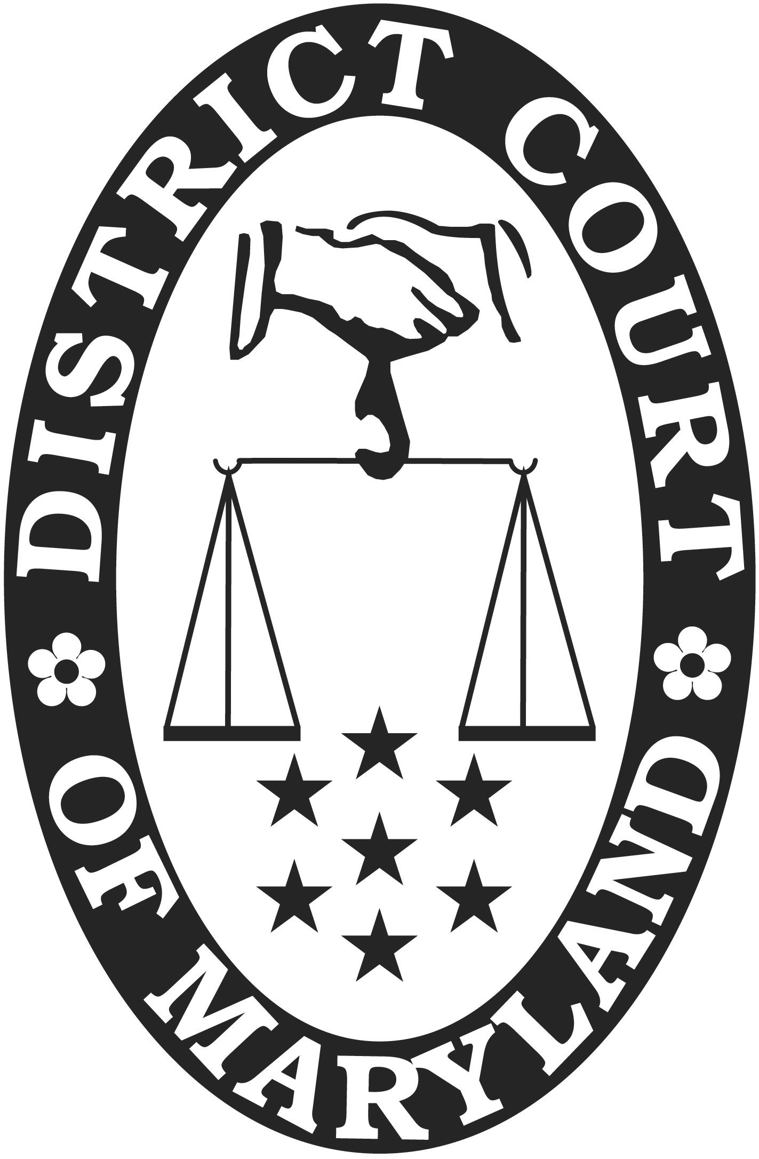
DISTRICT COURT OF MARYLAND TRIAL DATE: Trial Date
ADR SETTLEMENT AGREEMENT ADR Practitioner(s) ID #(s):

CASE NUMBER:
PLAINTIFF(S):
DEFENDANT(S):
The parties agree to the following:

ACKNOWLEDGED AND AGREED:
Plaintiff’s Attorney Signature (if applicable) Date Defendant’s Attorney Signature (if applicable) Date
Role Date Role Date
Plaintiff’s Signature Date Defendant’s Signature Date
 |  | Date |  |  |  | Date
 |  | Date |  |  |  | Date
 |  | Date |  |  |  | Date

If you have questions about this agreement or about next steps because of this agreement, you may contact the Maryland Courts Self-Help Center at 410-260-1392. The Self-Help Center is staffed by lawyers who provide limited legal information and advice. If you have any questions or comments about your experience in ADR, please contact the District Court ADR Office at 410-260-1676 or 1-866-940-1729.

Page # of #
ADR-004 (Rev. 08/2019), MDEC: ADRST

