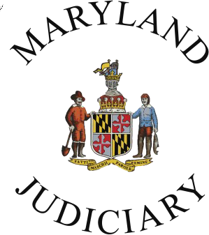
2022 Conflict Resolution Day Bookmark Art Contest Template
Sponsored by the Maryland Judiciary’s Mediation and Conflict Resolution Office (MACRO)
Entries must be received by Thursday, October 20, 2022
Please draw your bookmark entry in the box below. Be sure that your artwork is within the dotted border.
Please print clearly.

Student’s first and last name: Address to return artwork:
____________________________________________ _________________________________________

Age: __________ Grade: __________ _________________________________________

School: ______________________________________ _________________________________________

County: _________________________

Parent, guardian, or teacher’s first and last name: Teacher or parent email address:
___________________________________________ _________________________________________
For notification purposes if this entry is selected.

Tips
- For the best results, use bright or dark colors with crayons, markers, pens, or paint.
- If you use pencil in your drawing, please make sure it is dark enough to print.
- If your art includes words, make sure to double and triple check your spelling.
- See the reverse side for topic suggestions and other guidelines.

2022 Conflict Resolution Day Bookmark Art Contest
Sponsored by the Maryland Judiciary’s
Mediation and Conflict Resolution Office (MACRO)

This contest is open to all students in Maryland currently in grades K-8. Use the template on the reverse side of this form to create your original artwork. The theme of your submission should focus on peaceful conflict resolution such as listening, respecting differences, talking things out, tolerance, problem-solving together, and peer mediation. Entries can be created with markers, colored pencils, crayons, paint, and pencils, as well as digital art. All entries must be the original work of the student.

By submitting your bookmark entry, you give the Judiciary permission to use the artwork in any future public awareness materials promoting conflict resolution. Only one entry per student will be accepted. When printing this template, please use the landscape format.

If you have questions, please email Cheryl Jackson at bookmarkcontest@mdcourts.gov or call 410-260-3540.

Please mail or hand-deliver this entry to:
Maryland Judiciary
Attn: Cheryl Jackson
187 Harry S. Truman Parkway
Annapolis, MD 21401

Teachers and/or students, please include a return label. More information about the contest is available at: https://mdcourts.gov/macro/eventsconflictresolutionday2022.

All entries must be received by Thursday, October 20, 2022.

